**Project Design Phase-I**

**Solution Architecture**

|  |  |
| --- | --- |
| Date | 19 September 2022 |
| Team ID | PNT2022TMID22482 |
| Project Name | Project - **Smart Waste Management System For Metropolitan Cities** |
| Maximum Marks | 4 Marks |
| Team members | Saravanan G (Team lead)  Anand Krishnan N  Kishore Kumar J  Mohamed Idris M |

**Solution Architecture:**

Solution architecture of smart waste management system for metropolitan cities

* **Street waste bins are embedded with a sensor unit** 
  + **The sensor unit has Load sensor and ultrasonic sensor embedded in an Arduino-uno board**
  + **GPS is also attached in each node**
* **Node red cloud service used to process data modulations in each node (waste bins)**
* **Every Waste bin in every street in the cities are connected through IBM Watson IoT platform. Every data is stored in the IBM cloud services.**
* **A user interface is built to give information and alerts to workers such as,**
  + **Sensor data to check weather the bin is filled or not.**
  + **GPS data of bins that are filled**
* **Users get information about local waste bin truck’s location and arriving timings.**

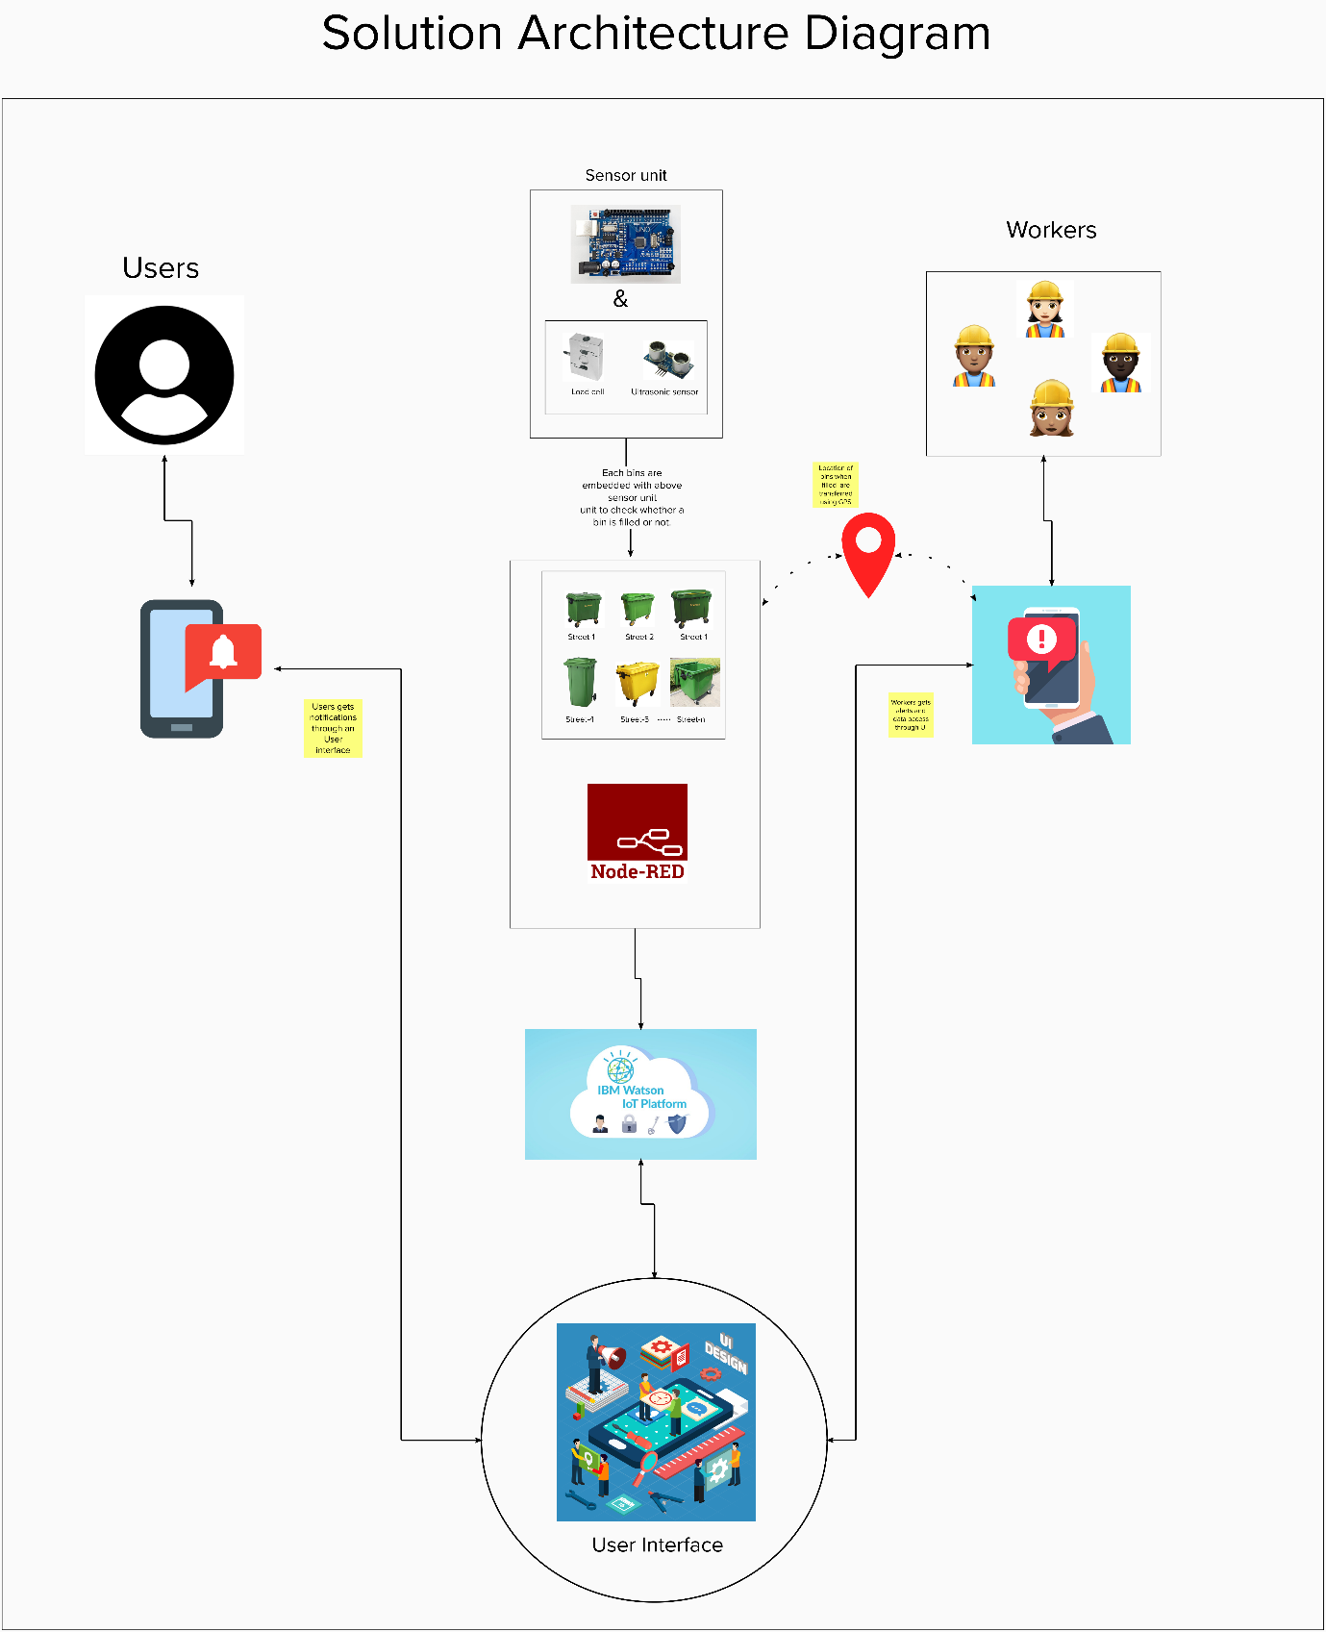

Architecture and data flow of Smart waste management sysytem

**Reference :**

[**https://app.mural.co/t/batch75990/m/batch75990/1665055867173/db98332f997aa3bd6b36b53c81ee47640ac2ef75?sender=ufb422529e3523c7e81c85623**](https://app.mural.co/t/batch75990/m/batch75990/1665055867173/db98332f997aa3bd6b36b53c81ee47640ac2ef75?sender=ufb422529e3523c7e81c85623)